EAC2 Proceedings manuscript

Name Surname *ª, Name Surname^{b},
ªDepartment…, University …, City, Country
^{b}Department…, University …, City, Country

Abstract
Begin the abstract two lines below the affiliations. The length of the abstract is approximately 100 words.

Keywords: Select up to 5 keywords, separated by comma

INTRODUCTION
Begin the Introduction two lines below the Keywords. The manuscript should not have headers, footers, or page numbers. It should be in a one-column format. References are noted in the text¹ by numerical superscript according to their appearance order and cited at the end of the paper. The maximum length of the whole paper is 6 pages for normal papers (please note that the minimum length of the whole paper is 4 pages). For plenary speakers only, the length of the whole paper can be extended to a maximum of 8 pages for plenary papers.

Margins
Please use the margins of Table 1 (same with this document).
Table 1. Margins and print area specifications.
PAPER MARGINS
A4
Top margin 2.5 cm
Bottom margin 3.5 cm
Left, right margin 1.9 cm

Fonts
Table 2 shows the font sizes and highlighting in a typical manuscript. These font "styles" are contained with this sample manuscript and Section 4 below explains how to use them. Use Times New Roman to avoid font errors.

*aaabbbccc@vub.ac.be; phone 0032 1234 5678
Table 2. Manuscript font sizes and formatting.

Paper title 16 pt. bold, center

Authors/affiliations 12 pt., center
Keywords: *Keywords* 10 pt., left justify

ABSTRACT TITLE 11 pt. BOLD, center
abstract body text 10 pt., justify

SECTION HEADING 11 pt. BOLD, center, whole numbers
Subsection heading 10 pt. bold, left justify, subsection numbers
body text 10 pt., justify
figure caption 9 pt., below figure, centered or indented
table caption 9 pt., center above figure
footnote text 9 pt., justify, numbered
REFERENCE HEADING 11 pt. BOLD, center
Reference listing 10 pt., justify, numbered in brackets

Formatting of manuscript components

Title
Center the paper title at the top of the page in 16-pt. bold. Only the first word, proper nouns, and acronyms are capitalized. Keep titles brief and descriptive. Spell out acronyms unless they are widely known. Avoid starting with articles or prepositions, e.g., “The study of … ,” or, “On the ….”

Author affiliations
The author list is in 12-pt. regular, centered. The list of affiliations follows. Each author's affiliation should be clearly noted by a superscript.

Section headings
Section headings are 11-pt. bold capitals, centered. Sections numbers have whole numbers, e.g., 1, 2, 3… Do not number the "Acknowledgements" and "References."

Subsection heading
Subsection headings are left-justified, 10-pt. bold. Capitalize the first word, acronyms, and proper nouns.

Paragraphs
Add a blank line above and below section headings and between paragraphs.

Text
Text is 10 point and fully justified. Each sentence ends with a period and a single space before the next sentence.

Tables and figures
Tables are centered. The caption goes above the table. The caption text should indent 5 spaces from left margin and justify. Table examples are on page 1 and 2 and below.
Figures are centered. The caption goes below the figure. The caption text should indent 5 spaces from left margin and justify. A table example is shown below.

Table 1. Material properties
Material | Compressive Strength (MPa) | Young modulus (GPa)
Concrete | 52.4 | 36.2
GFRP.IPC | 80 | 3.8-10.1
CFRP | - | 137.0
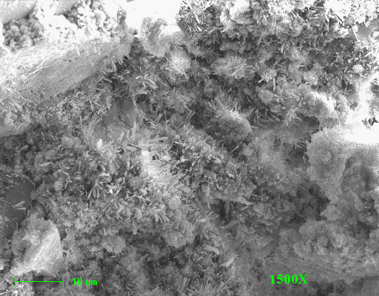
Figure 1. Figure captions are centered as well as the figures.

Mathematical Equations
Use common fonts like Times Roman. The different equations are numbered using a number in parenthesis at the right of the line, for example
α = (1)

References
- De Sutter, S., Tysmans, T., Wozniak, M.: Analytical modeling and experimental testing of hybrid composite-concrete beams in a lightweight floor system. In: El-Hatcha, R. (ed.) Proceeding of the 7th International Conference on FRP Composites in Civil Engineering (CICE2014), Vancouver, Canada, August 2014, ISBN 978-1-77136-308-2
- Grosse CU, Ohtsu M. Acoustic emission testing. Heidelberg: Springer; 2008.
- De Sutter, S., Remy,O., Tysmans, T.,Wastiels, J.: Development and experimental validation of a lightweight stay-in-place composite formwork for concrete beams. Constr. Build. Mater. 63, 33–39 (2014)
- http://www.cost.eu/COST_Actions/tud/TU1404 (last accessed Feb. 2017)

